Public transport optimization

Phase 3 project

**Introduction:**

Optimizing public transport involves various aspects such as route planning, scheduling, and passenger information systems. It can be a complex task depending on the specific goals and constraints. Below, I'll provide a basic Python code example for optimizing bus routes using a genetic algorithm. This is a simplified illustration, and real-world public transport optimization projects are typically much more complex.

**Components required and system design:**

Optimizing public transport systems involves integrating various components and technologies to enhance efficiency, convenience, and sustainability. Here are some key components and strategies that can contribute to the optimization of public transport:  
  
1**. Intelligent Transport Systems (ITS**):

Implementing ITS can improve the overall efficiency and safety of public transportation networks. This includes technologies such as real-time passenger information systems, traffic signal priority for buses, and automatic vehicle location systems.  
  
2**. Integrated Ticketing and Payment Systems:**

Developing a seamless, integrated ticketing and payment system across different modes of public transport simplifies the process for passengers. This can include contactless payment methods, smart cards, and mobile ticketing applications.  
  
3. **Fleet Management and Maintenance**:

Regular maintenance and effective management of public transport fleets are essential for ensuring operational efficiency and passenger safety. Implementing predictive maintenance technologies can help prevent breakdowns and improve overall fleet reliability.  
  
4**. Infrastructure Development**:

Investing in well-planned infrastructure, such as dedicated bus lanes, priority signaling, and intermodal transit hubs, can significantly improve the speed and reliability of public transportation services.  
  
5**. Data-Driven Decision Making:**

Leveraging data analytics and passenger feedback to make informed decisions about route planning, scheduling, and service adjustments can lead to better optimization of public transport operations.  
  
6**. Eco-friendly Initiatives**:

Introducing environmentally friendly technologies and fuel-efficient vehicles, such as electric buses and hybrid trains, can contribute to reducing the carbon footprint of public transportation systems and promoting sustainable urban mobility.  
  
7. **Accessibility and Inclusivity**:

Ensuring that public transport services are accessible to people with disabilities and cater to the needs of all passengers promotes inclusivity and enhances the overall user experience.  
  
8. **Public-Private**

Partnerships (PPPs): Collaborating with private entities for the development and operation of public transport systems can bring in additional expertise and funding, facilitating the implementation of innovative solutions and improving service quality.  
  
By integrating these components and strategies, authorities can work towards creating an efficient, sustainable, and user-friendly public transport system that meets the diverse needs of urban and suburban communities.

**Python code:**

Import random  
  
# Constants  
POPULATION_SIZE = 10  
MUTATION_RATE = 0.1  
GENERATIONS = 100  
  
# Sample data (can be replaced with real data)  
bus_stops = [(1, 1), (2, 2), (3, 3), (4, 4), (5, 5)]  
bus_routes = [[0, 1, 2, 3, 4], [4, 3, 2, 1, 0]]  # Sample initial routes  
  
  
# Function to calculate the total travel time for a bus route  
def calculate_total_time(route):  
    total_time = 0  
    for i in range(len(route) - 1):  
        total_time += abs(bus_stops[route[i]][0] - bus_stops[route[i + 1]][0]) + abs(  
            bus_stops[route[i]][1] - bus_stops[route[i + 1]][1]  
        )  
    return total_time  
  
  
# Genetic Algorithm  
def genetic_algorithm():  
    population = [bus_routes] * POPULATION_SIZE  
  
    for generation in range(GENERATIONS):  
        population = sorted(population, key=lambda x: calculate_total_time(x))  
        fittest = population[0]  
  
        new_population = [fittest]  
  
        for _ in range(POPULATION_SIZE - 1):  
            parent1 = random.choice(population[: POPULATION_SIZE // 2])  
            parent2 = random.choice(population[: POPULATION_SIZE // 2])  
            child = []  
            for i in range(len(bus_stops)):  
                if random.random() < MUTATION_RATE:  
                    child.append(random.randint(0, len(bus_stops) - 1))  
                else:  
                    if random.random() < 0.5:  
                        child.append(parent1[i])  
                    else:  
                        child.append(parent2[i])  
            new_population.append(child)  
  
        population = new_population  
  
    return sorted(population, key=lambda x: calculate_total_time(x))[0]  
  
  
# Run the Genetic Algorithm and print optimized routes  
optimized_routes = genetic_algorithm()  
for i, route in enumerate(optimized_routes):  
    print(f"Bus {i + 1} Route: {route}")

long get_distance1() {

  // Start a new measurement:

  digitalWrite(PIN_TRIG1, HIGH);

  delayMicroseconds(10);

  digitalWrite(PIN_TRIG1, LOW);

  // Read the result:

  duration1 = pulseIn(PIN_ECHO1, HIGH);

  distance1 = duration1 / 58;

  return distance

}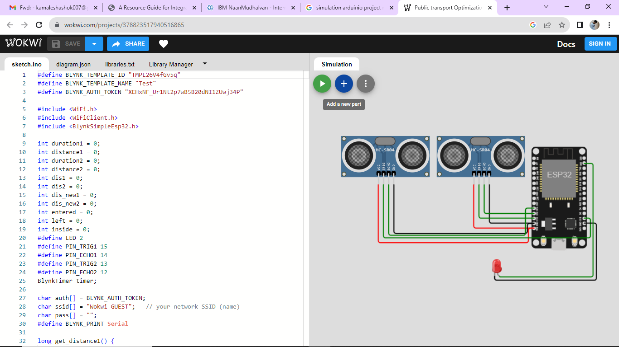

1. **Network Design and Planning:** The first step in optimizing connections is designing an efficient network of routes and modes (buses, trams, subways, trains, etc.). This involves analyzing the demand, population density, and traffic patterns in a region to determine the best routes and stops.

2. **Timetable Synchronization:** Coordinating schedules among different modes of transport (e.g., buses, trams, and trains) is critical for seamless connections. Passengers should be able to transfer from one mode to another with minimal waiting times.

3. **Intermodal Hubs:** Creating well-planned intermodal hubs or transfer points allows passengers to switch between different modes of transport easily. These hubs should have clear signage, comfortable waiting areas, and real-time information on departures.

4. **Real-Time Information:** Passengers need access to real-time information about the status and location of their connections. This includes apps, websites, digital signage at stations, and in-vehicle displays.

5. **Fare Integration:** Implementing fare integration or smart card systems that work across various modes of transport simplifies the payment process and encourages the use of public transport.

6. **Multi-Modal Trip Planning Apps:** Develop and promote apps that enable passengers to plan multi-modal journeys easily, including options for real-time updates, route suggestions, and ticket purchasing.

7. **Traffic Management and Priority Lanes:** Implementing dedicated lanes or traffic management measures for public transport vehicles can help ensure they stick to schedules and maintain good connections.

8. **Optimization Algorithms:** Utilize optimization algorithms and software to improve scheduling, routing, and resource allocation. These algorithms can adapt to changing demand and traffic conditions.

9. **Transit Oriented Development (TOD):** Encourage development around transit stations, creating mixed-use neighborhoods that reduce the need for long commutes and promote public transport usage.

10. **Accessibility:** Ensure that the entire public transport system is accessible to people with disabilities. This includes accessible vehicles, stations, and pathways for smooth transfers.

11. **Environmental Considerations:** Promote environmentally friendly modes of transport, such as electric buses or trains, to reduce pollution and energy consumption.